Probability rules:

**Rule 1: complement Rule**

**P(Ac)=1-P(A)**

P(Ac) is the prob that A doesn’t happen

P(A) is the probs that A happens

|  |  |  |  |
| --- | --- | --- | --- |
|  | Glasses | No glasses | total |
| Black hair | 12 | 8 | 20 |
| Not black hair | 3 | 10 | 13 |
| total | 15 | 18 | Total total 33 |

P(black hair or glasses)=(20+15-12)/33=23/33=69.7%

**Rule2:**

**Addition Rule**

**P(A or B)=P(A)+P(B)-P(A and B)**

B

If A and B are mutually exclusive, then P(A and B)=0

P(A or B)=P(A)+P(B)

**Rule3: Multiplication Rule:**

**P(A and B)=P(A)*P(B|A) or P(B)*P(A|B)**

-------- If A and B are independent P(B|A)=P(B), P(A and B)=P(A)*P(B)

***Ex2:***

4 red, 3 blue marbles

P(2red ***W/O*** replacement)

P(red and red)=P(1st red)xP(2nd red|1st red)=4/7 * 3/6=12/42=2/7=28.6%

P(2red ***WITH*** replacement)

P(red and red)=P(1st red)*P(2nd red|1st red)=4/7 * 4/7=16/49=32.7%

****When population is huge and sample size is small(less than 5%), on the test, state that: ***assuming independent due to small sample, sample<5% of pop***

“none” and “at least one” are complements

***Ex5***

P(none have fakitis)=[P(not fakitis)]^10=0.98^10=0.8171

P(at least one fakitis)=1-P(none)=1-0.8171=0.1829=18.29%

**Rule4: Conditonal Probability  
P(B|A)=P(A and B)/P(A)**

**P(A|B)=P(A and B)/P(B)**

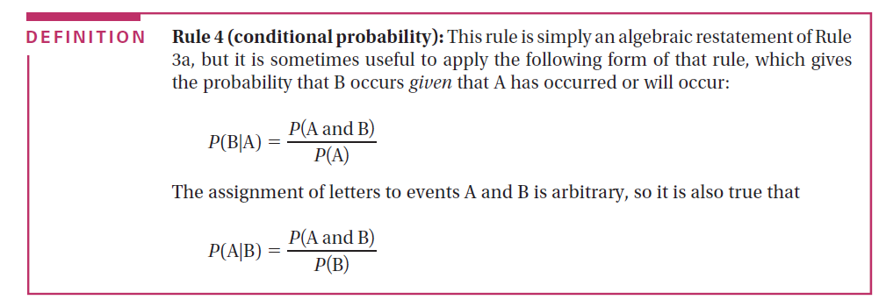

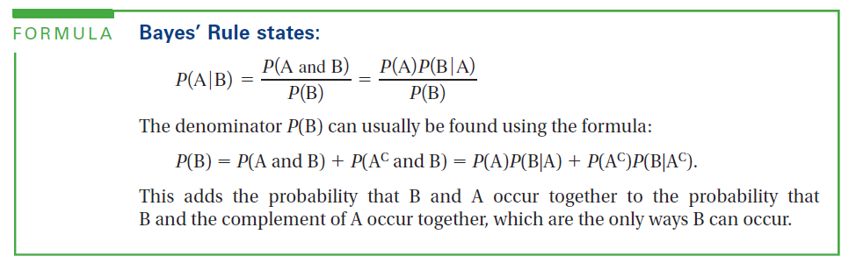

EX (fakitis)

99% accurate for those with fakitis

P (positive|have fakitis)=0.99 🡨 sensitivity

95% accurate for those without fakitis

P (negative|not fakitis)=0.95 🡨specificity

P(fakitis)=0.02

P(not fakitis)=0.98

We are looking at P(fakitis|positive)=P(fakitis)*P(positive|fakitis)/P(positive) F=fkitis P=positive N=nagetive

=P(F)*P(P|F)/[P(F)*P(P|F)+P(not F)*P(P|not F)]=(0.02)(0.99)/[(0.02)(0.99)+(0.98)(0.05)]=0.2878=28.78%

|  |  |  |  |
| --- | --- | --- | --- |
|  | Test pos | Test neg |  |
| Have fakitis | 1980 | 20 | 2000 |
| Don’t have fakits | 4900 | 93100 | 98000 |
| total | 6880 | 93120 | 100,000 |

P(fakitis|posirive)=1980/6880=28.78%